EIC(ECONOMICAL,INDUSTRIAL,

COMPANY ANALYSIS) REPORT BY-DIVYANSHU KHATTAR

Quantative Analysis

 Economic [indicators](https://www.investopedia.com/terms/c/cci.asp) provide insight about the state of an economy and whether it is in expansion or contraction. Most indicators are released monthly by government agencies and typically provide input on activity in the previous month and year for comparison purposes.

Here are the top quantative economic indicator which are important for analysis country-

WEIGHTAGE

|  |  |
| --- | --- |
| GDP PER CAPITAL | 12% |
| GDP ANNUAL GROWTH RATE | 8% |
|  |  |
|  |  |
| National Debt to GDP Ratio | 16% |
|  |  |
|  |  |
| inflation index | 16% |
|  |  |
|  |  |
| Govt Budget | 7% |
| Foreign Exchange Reserve | 7% |
|  |  |
|  |  |
| Real Interest rate(%) | 8% |
|  |  |
|  |  |
| CURRENT ACCOUNT | 14% |
|  |  |
|  |  |
| Unemployment Rate | 12% |
|  |  |

**1.)GDP**

1. GDP per capita(Weightage:-12%)

Gross Domestic Product (GDP) per capita **shows a country's GDP divided by its total population**.

[GDP](https://www.investopedia.com/terms/g/gdp.asp), of an economy provides the overall value of the goods and services it produces and indicates whether an economy is growing or slowing.

#### **Why this economic indicator ?**

* It is one of the most common indicators used to track the health of a nation's economy.
* **Gives information about the size of the economy and how an economy is performing**.
* **Enables policymakers and central banks to judge whether the economy is contracting or expanding and promptly take necessary action**

**2.) GDP Annual Growth Rate(8%)**

The **annual average rate of** change **of** the **gross domestic product** (**GDP**) at market prices based on constant local currency, for a given national economy, during a specified period **of** time.

#### **Why this economic indicator ?**

* **Gives information about the size of the economy and how an economy is performing**. The growth rate of real GDP is often used as an indicator of the general health of the economy. In broad terms, an increase in real GDP is interpreted as a sign that the economy is doing well.

2) Debt to GDP Ratio(16%)

* This ratio tells analysts how much money the country earns every year, and how that compares to the money that country owes. The debt is expressed as a percentage of GDP.
* The debt-to-GDP ratio is the ratio of a country's public debt to its gross domestic product (GDP).

#### **Why this economic indicator?**

* The higher the debt-to-GDP ratio, the less likely the country will pay back its debt and the higher its risk of default, which could cause a financial panic in the domestic and international markets.

### The Debt-to-GDP Ratio Can Signal a Recession

As a country's debt-to-GDP ratio rises, it often signals that a [recession](https://www.thebalance.com/what-is-a-recession-3306019) is underway.

3)Inflation(16%)

[Inflation](https://www.investopedia.com/terms/i/inflation.asp) is the general price level rise of goods and services in an economy. *Too much inflation can mean the economy is "overheating" while very low inflation can be a harbinger of economic recession.*

#### **Why this economic indicator is?**

* basic indicator to see whether your country and other economies are in shape or not.
* Understanding inflation is crucial to **investing because inflation can reduce the value of investment returns**.

**4.)GOVT BUDGET(7%)**

Government budget is used **to prevent business fluctuations of inflation or deflation to achieve the objective of economic stability**. The government aims to control the different phases of business fluctuations through its budgetary policy.

: 1. Reallocation of Resources 2. Reducing inequalities in income and wealth 3. Economic Stability 4. Management of Public Enterprises 5. Economic Growth and 6. Reducing regional disparities.

**5)FOREIGN EXCHANGE RESERVE(7%)**

Foreign exchange reserves (also called forex reserves or FX reserves) are **cash and other reserve assets such as gold held by a central bank or other monetary authority** that are primarily available to balance payments of the country,

#### **Why this economic indicator is?**

* Influence the foreign exchange rate of its currency
* It's developed a positive sentiment that the country has the ability to meet its external debt obligation and **foreign exchange** needs.

**6.)REAL INTEREST RATE(8%)**

The real interest rate, that is the nominal interest rate minus expected inflation, is the **rate that influences decisions concerning saving and investment**

#### **Why this economic indicator is?**

Monetary economics and policies suggest that interest rates majorly drive economic activity.

During the financial crisis of 2008 we’ve known about, [**credit spread**](https://www.wallstreetmojo.com/credit-spread/) blew over the roof and caused corporate distress and defaults.

* 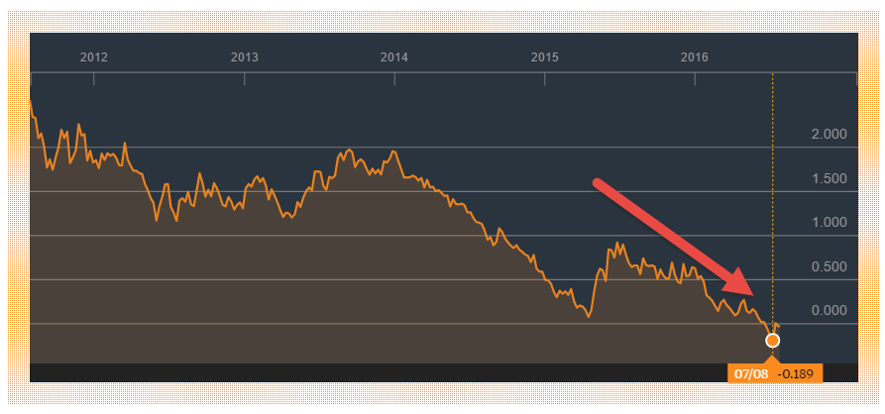 The real interest rate reflects the purchasing power value of the interest paid on an investment or loan and represents the rate of time-preference of the borrower and lender.

**7.)Current account(14%)**

* A **country's current account** records the value of exports and imports of both goods and services and international transfers of capital. ... It is called the **current account** because goods and services are generally consumed in the **current** period.

#### **Why this economic indicator is?**

* The current account is an important metric for any country because **it measures current trade activities, direct investments, and the success of assets held by residents of the country**.
* Countries use the **current account** the balance of payments as an **important macroeconomic indicator** of the viability of the economy. It is a useful economic **indicator** because it represents other **important** economic variables

**8)Unemployment Rate(12%)**

The unemployment rate is a useful measure of **the underutilization of the labour supply**. ... It is thus seen as an indicator of the efficiency and effectiveness of an economy to absorb its labour force and of the performance of the labour market.

#### **Why this economic indicator is?**

* **Uses to determine the health of the economy when setting monetary policy**. Investors also use current unemployment statistics to look at which sectors are losing jobs faster. They can then determine which sector-specific mutual funds to sell.
* The unemployment rate is a [lagging indicator](https://www.thebalance.com/lagging-economic-indicators-list-index-and-top-3-3305860). This means it measures the effect of economic events, such as a recession.

Conclusion

Top 3 best countries based on Quantative economic analysis are- **Iceland, Netherland and south korea**

Top 3 worst countries based on Qualitative economic analysis are:- **Iraq ,Brazil,Pakistan**

**QUALITATIVE ECONOMIC ANALYSIS**

Here are the top qualitative economic indicator which are important for analysis country—

WEIGHTAGE

|  |
| --- |
| **Global Peace Index---- 20%** |
|  |
| **Trade Restrictiveness Index 6%** |
|  |
| **Corruption Perception Index 12%** |
|  |
| **Business Ethics National Index 4%** |
| **World Index Of Moral Freedom 6%** |
|  |
|  |
| **Global Competitive index 7%** |
|  |
|  |
| **Human Development Index 10%** |
| **Quality Of Life Index 5%** |
| **Environmental Performance Index 6%** |
| **Climate Change Performance Index 4%** |
|  |
| **Ease of doing business 10%** |
| **Rule of law index 5%** |

**1.)GLOBAL PEACE INDEX(20%)**

**Global Peace Index** (**GPI**) is a report produced by the Institute for Economics & Peace (IEP) which measures the relative position of nations' and regions' peacefulness.

**Why this economic indicator is?**

he GPI investigates the extent to which countries are involved in ongoing domestic and international conflicts and seeks to evaluate the level of harmony or discord within a nation.

2.) TRADE RESTRICTIVE INDEX(6%)

**A new tool that identifies, catalogues, and quantifies cross-cutting barriers that affect services traded digitally**

**Why this economic indicator ?**

* Calculating the uniform tariff that will keep its overall imports at the current level when the

country in fact has different tariffs for different goods.

3.) CORRUPTION PERCEPTON INDEX(12%)

* The Corruption Perceptions Index (CPI) is an index which ranks countries "by their perceived levels of public sector corruption, as determined by expert assessments and opinion surveys." The CPI generally defines corruption as an "abuse of entrusted power for private gain".

**Why this economic indicator is?**

* Low CPI ranking indicates a high level of corruption while higher rankings indicate a clean system.
* Experts suggest that corruption disadvantages the economically challenged and those who rely heavily on public services.
* Corruption continues to be a big hurdle to political, economic, and social development.

**4.)** Business Ethics National Index(4%)

* Provides a **questionnaire to the various contributing authors**. **by which to assess business ethics** activity in their respective countries.

**Why this economic indicator is?**

* **enhances the law by outlining acceptable behaviors beyond government control**.
* To promote integrity among their employees and gain trust from key stakeholders, such as investors and consumers

5.) WORLD INDEX OF MORAL FREEDOM(6%)

The index measures the level of moral coercion across countries, i.e. how much governments across the world force their citizens to act in line with an officially sanctioned set of values.

**Why this economic indicator is?**

* It tells us how free is your country from state-imposed **moral** constraints

6.) Global Competitive index(7%)

GCI is defined by the World Economic Forum. It is a set of institutions, policies, and factors that determine the level of productivity of a country, conditions of public institutions and technical conditions

**Why this economic indicator is?**

* **Analyzes the economic foundations of nearly all countries in order to evaluate each country's competitiveness for achieving sustained economic productivity, growth and prosperity**

**7.) Human Development Index(10%)**

The Human Development Index is a statistic composite index of life expectancy, education, and per capita income indicators, which are used to rank countries into four tiers of human development.

**Why this economic indicator is?**

* **Measures the socio economic factors** and therefore, is considered very effective in measuring the performance of a country in terms of these factors.

**8)** Quality Of Life Index(5%)

**It measure of the quality of life or well-being of a country**. The index provides an overall look at the health and literacy of a country, state, or city and can be used to identify areas of the index that should be improved. ...

**Why this economic indicator is?**

* **It allows development to be analyzed on a measure that is generally accepted as more comprehensive than standard of living**.
* **Highly subjective measure of happiness that** is an important component of many financial decisions.

9.) Environmental Performance Index(6%)

* Provides a data-driven summary of the state of sustainability around the world. indicators provide a gauge at a national scale of how close countries are to established environmental policy targets

**Why this economic indicator is?**

* It offers a scorecard that **highlights leaders and laggards in environmental performance** and provides practical guidance for countries that aspire to move toward a sustainable future.

10) Climate Change Performance Index(4%)

The **Climate Change Performance Index** is an instrument designed to enhance transparency in international climate politics

**Why this economic indicator is?**

* Enables comparison of climate protection efforts and progress made by individual countries.

**11)** Ease of doing business(10%)

* **Measure of institutional quality as a proxy for a country's performance in promoting a business environment**.

**Why this economic indicator is?**

* Ease of doing business is predominantly  **can lead India's economic growth and generate employment for millions across the country** and contributes about 30% to the country's GDP.

12) Rule of law index(5%)

The World Justice Project is an international civil society organization with the stated mission of "working to advance the rule of law around the world

measures how the rule of law is experienced and perceived in 128 countries

**CONCLUSION-**

Top 3 best countries based on Qualitative economic analysis are- **ICELAND,NETHERLAND AND UNITED KINGDOM**

Top 3 worst countries based on Qualitative economic analysis are:- **PAKISTAN,AFGHANISTAN,IRAQ**

INDUSTRY ANALYSIS OF FMCG

FAST MOVING CONSUMER GOODS (FMCG) 

Table Of Content

* Definition
* Market Overview
* PESTEL ANALYSIS
* BCG MATRIX OF BRITANNIA

**Introduction**

* FMCG sector is the **fourth-largest** sector in the Indian economy.
* Fast-moving consumer goods (FMCG) or consumer packaged goods (CPG) are products that are sold quickly and at relatively low cost.
* The FMCG market in India is expected to grow at a CAGR of 23.15% to reach US$ 103.70 billion by FY21 from US$ 68.38 billion in FY18.
* Final consumption expenditure is set to increase at a CAGR of 25.44% during 2017-2021. It is expected to reach nearly US$ 3.60 trillion by 2020 from US$ 1.82 trillion in 2017
* By 2025, India is likely to be the **fifth-largest** FMCG market

FMCG Market Share

. The main FMCG segments can be classified as Personal Care, Household care, Branded and Packaged food and Tobacco

* **Personal Care***:* It consists of oral care; hair care; skin care; personal wash (soaps); cosmetics and toiletries; deodorants; perfumes; paper products (tissues, diapers, sanitary); shoe care etc.
* **Household Care**: It comprises of fabric wash (laundry soaps and synthetic detergents); household cleaners (dish/utensil cleaners, floor cleaners, toilet cleaners, air fresheners, insecticides and mosquito repellents, metal polish and furniture polish).
* **Branded and Packaged Food and Beverages**: It con- sists of health beverages; soft drinks; staples/cereals; bakery products (biscuits, bread, cakes); snack food; chocolates; ice cream; tea; coffee; processed fruits, vegetables and meat; dairy products; bottled water; branded flour; branded rice; branded sugar; juices etc.
* **Spirits and Tobacco**: An exact product-wise sales break up for each of the items is difficult.

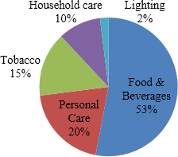

## Most trusted Brands of (FMCG)

|  |  |  |  |
| --- | --- | --- | --- |
| Brand | Ranking | Brand | Ranking |
| Colgate | 1 | Britannia | 11 |
| Dettol | 3 | Rin | 13 |
| Maza | 4 | Parle | 14 |
| Magi | 5 | Life boy | 15 |
| Lux | 6 | Tata salt | 16 |
| Surf Excel | 7 | Cadbury Dairy Milk | 18 |
| Clinic Plus | 8 | Kurkure | 19 |
| Frooti | 10 | Glucan- D | 20 |
| ( Source : Economic  Times ) |  |  |  |

3.60

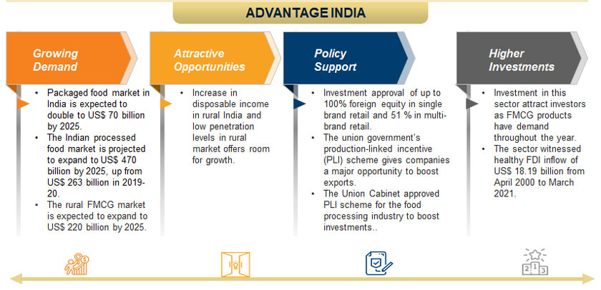PESTEL ANALYSIS

Pestel analysis is a tool to understand the environment in which business operates, & the opportunities & threats that lie within it. By understanding the environment in which it operates, it can take advantage of the opportunities & minimizing the threats. Specifically PESTEL analysis is useful tool for understanding risks associated with markets growth or decline, & directing business to grow.

P-Political Factor

E- Economical Factor

S- Socio-cultural Factor

T- Technological Factor

E- Environmental Factor

L- Legal Factor

**1.)POLITICAL FACTOR**

•        **Political stability:** It influences the growth of business. If it higher business is stable.

* The Prevention of Food Adulteration Act, 1954

•        **Taxation policy:**It will affect the price of input which in turm will affect the price of output.

*As per the current*tax*regime,*FMCG*has to pay many*taxes*like VAT, Service*Tax*, Excise Duty, Central Sales*Tax*.*

•        **Governement Intervenes:**If the government intervence is more it sometimes help the organization.

•        **Subsidies:**It helps the organization to grow faster and reduce its finance cost.

•        **Trading Policies**:If these policies are good, it will help in more import and export of goods

FOR EXAMPLE-**National Retail Trade Policy**

This policy is being formulated to support the development of the sector that is claimed to benefit 65 million small trader

**. Labour Law** :- Labour law also affect the organisation,

for example- child labour, a child below14 year of age can not work In factory or any hazardious place

2)Economical Factor

Economic factors have a significant impact on how an organisation does business and also how profitable they are. Factors include – economic growth, interest rates, exchange rates, inflation, disposable income of consumers and businesses and so on.

* **GDP Growth:** Growth of FMCG industry is consistent with the Indian economy. It has grown by **15 %** over past 5 years. It shows good scope for this sector in near future.
* **Inflation:** Inflationary pressures alter the purchasing power of consumer which Indian economy is facing in recent years. But it has not affected much to Indian FMCG sector.

*The economy was growing at a faster rate, imput prices were low, and inflation was low. This year the food inflation is very high around 12%, and the raw material cost has increased upto 15 to 20 percent compared to last year.*

* **Consumer Income:** Over the past few years, India has seen increased economic growth. The GDP per capita in- come of India increased from 797.26 US dollars in 2006 to 1262.4 US dollars in 2014 . It resulted in increase of consumer expenditure
* **Private Consumption:** The Indian economy, unlike other economies, has a very high rate of **private consumption (61%).**
* **Interest rates** : Interest rate directly affect the cost of capital, if the interest rate is higher the cost of capital will increase & if it is lower then cost of capital will be lower.

This directly affect the ***profit of the organization & it’s growth***.

3) **SOCIO CULTURAL FACTORS**

•        **Demographics:**It divides the market into segment to target customers. *Rapid urbanization, increased literacy, increase in nuclear families and rising per capita income, have all caused rapid growth and change in demand patterns, leading to an explosion of new opportunities*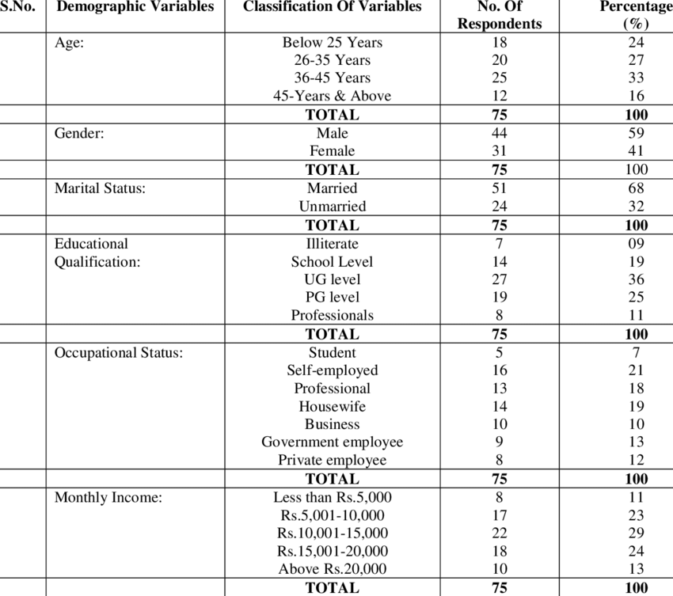

•        **Change if Lifestyle:**If leads to increase and decrease in demads of different commodities according to thelifestyle of customers.

Eg*- In past decade changes are taking place in consumption pattern of Indian consumer with more spending on discretionary ( 52%) than necessities ( eg food, clothings).*

*In last decade the apparel, footwear and healthcare segments have registered highest growth whereas essentials such as cereals, edible oil, fruits and vegetables shown*

•        **Consumerism:**It tells that customer has vast choices of products to choose from.

• **Rural focus:**

As market is getting saturated, companies are focusing on rural area for penetration by providing consumers with small sized or single-use packs such as sachets

4) **TECHNOLOGICAL FACTORS**

1. **An ordering app** – It enables retailers to place contactless orders safely and also provides them visibility about the fulfilment of such orders through logistics tie-ups and intuitive interfaces.

1. ) Digitising factories and building automated warehouses unlock capacities and make operations agile. All of this is powered by **intelligent data** and analytics, ensuring smooth and optimised operations.

1. **Warehouse Management System-**

* Reduce warehouse, ordering and inventory expenses

1. **S/4 HANA**

* It provide the company with plant management and project management systems
* It will improve day-to-day operational efficiency

5.) **Arteria (the company’s dealer management system**)

* provides real time data.
* integrated system, and includes scheme management or discount management, claim settlements with distributors, pricing and promotion controls.

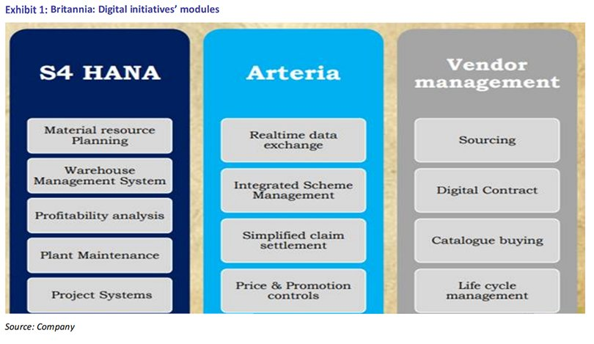

5)  **ENVIRONMENTAL FACTORS**

**Ecological:**The ecological factors such as weather, climate etc affect many industry.

**The Water (Prevention and Control of Pollution) Act, 1974 (Water Act)-** *“no person shall knowingly cause or permit any poisonous, noxious or polluting matter determined in accordance with such standards as may be laid down by the State Board to enter (whether directly or indirectly) into any stream or well or sewer or on land”.*

•        **Environmental issues:**It affects the organization as external factor.

**Plastic Waste Management (Amendment) Rules, 2018**.- *Every vendor, who sold commodities in a carry bag would have to register with their respective urban local body and pay a minimum fee of Rs 48,000 per annum (4000/month) after the announcement of the bye-laws*

•        **Environmental Regulations:**Various regulations has been declared by government to protect environment

**Section 26A of the Drugs and Cosmetics Act, 1940 (Drugs Act)-** *provides for the powers of the Central Government to prohibit manufacture etc of drug and cosmetic in public interest.*

6) **LEGAL FACTORS**

**Consumer Protection**: It protects the right of customers.

* **The Prevention of Food Adulteration Act, 1954. -***An Act to make provision for the prevention of adulteration of food*
* **The Fruit Products Order, 1955.** - *objective to manufacture fruit & vegetable products maintaining sanitary and hygienic conditions in the premises and quality standards laid down in the Order.*
* **The Meat Food Products Order, 1973.-** *Enforce strict quality control on the productio0n and processing of meat food products*
* **The Vegetable Oil Products (Control) Order, 1947**.-*Implementation of the standards of quality of the vegetable oil product mainly at the manufacturing stage.*

## CONCLUSION

* In India, FMCG Industry is a boom. This industry has been growing day by day from the day it has been established.
* Economic condition, political condition and social condition will be affecting less to this sector.

The very reason for this is no matter what happens, people will not stop buying the products that are essential to them in day-to-day life. Moreover, in the current scenario, there is an upliftment in the living standard of people in India. They are moving to middle-level category which means there is increase in their purchasing power. This has contributed to the rise of FMCG companies in India.

* As there are more competition in the FMCG sectors, people are also having more options to choose from. This has also made shopping of FMCG more fun and has helped to make the life of people easier.
* There are less barriers to entry and exit in the FMCG industry in India but the main problem here is the sustainability. As there is large number of competitions, survival becomes tough in this sector. One of the major obstacles in FMCG industry is, consumers can be brand loyal for a short period of time but in the long term, there can shift to a different brand

*Among the five companies (ITC, HUL, Dabur, Godrej, P&G) that we have analyzed, ITC has been the leader among the rests. The reason for this is ITC has made huge investment in FMCG segment which helped it to grow at such a fast pace.*

PRODUCT POTFOLIO OF BRITANNIA

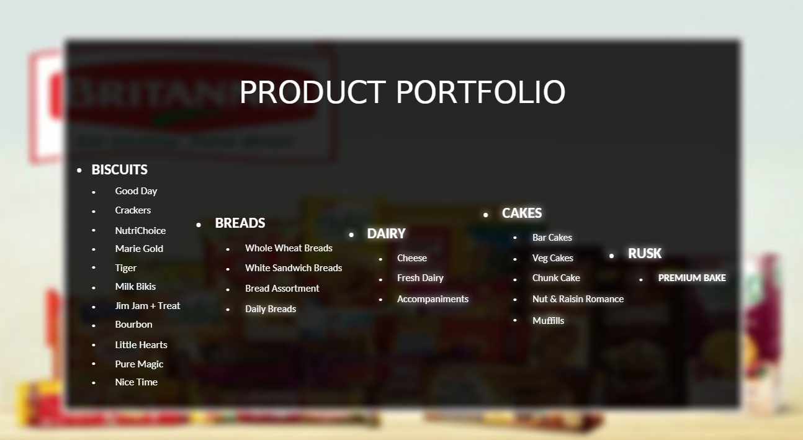

### **What is the BCG Matrix?**

The Boston Consulting group’s product portfolio matrix (BCG matrix) is designed to help with long-term strategic planning, to help a business consider growth opportunities by reviewing its portfolio of products to decide where to invest, to discontinue or develop products. It's also known as the [Growth/Share Matrix](https://www.smartinsights.com/digital-marketing-strategy/online-business-revenue-models/essential-marketing-strategy-models-growthshare-matrix/).

The Matrix is divided into 4 quadrants based on an analysis of market growth and relative market share, as shown in the diagram below.

* **1. Dogs:** These are products with low growth or market share.
* **2. Question marks or Problem Child:** Products in high growth markets with low market share.
* **3. Stars:** Products in high growth markets with high market share.
* **4. Cash cows:** Products in low growth markets with high market share

**BCG MATRIX OF BRITANNIA PRODUCT**

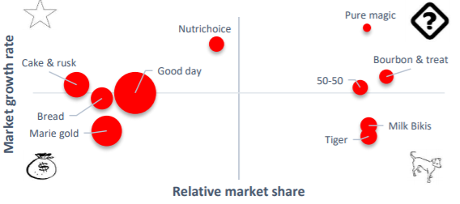

## Cash Cows

The first category that has been considered in the BCG Matrix is cash cows which includes all those products that serve as the financial foundation for an organization. These products have a high market share and are in high demand by the consumers which helps in securing a significant amount of profit.

There are 3 products that can be identified as cash cow for Britannia, -

1. **Good Day**
2. **, Marie Gold**
3. **Treat.**

Explanation

1. **Good Day**
   * **Good Day** biscuit has received a change in terms of its packaging, branding and marketing which has resulted in higher sales of the product. Even before these changes, Good Day had been a key source of earning for Britannia.
   * The company has added new items in the range of Good day such as Good Day cookies which has helped in bringing in higher level of profits for the firm, making it a cash cow.
2. **Marie Gold**
   * Marie Gold is one such brand manufactured by Britannia that has helped the company in dealing with **competitive pressure** from rival firms such as Parle.
3. **Treat.**
   * Treat is another biscuit manufactured by Britannia that is a cash generator as it has a **high demand** among the Indian consumers.

## Stars

These products have two main defining features. Firstly they have a high market share, secondly they seem to have further chances of development in terms of increased sales and market share.

The stars make a good option for financial investment as the company can gain significant return on the resources invested in this domain.

Britannia has several products that are stars for the company,-

* **Tiger**
* **Nutri Choice**

Explanation

1. Tiger

Tiger biscuit playing a significant role in strengthening the financial performance of Britannia. The decision to reshape the brand has been a supporting step in strengthening the position of this product in the BCG matrix

***Cake, Rusk and Bread are growing at a healthy rate in organized sector and Britannia is already market leader in this categories, we have considered them as partly rising star and partly cash cow.***

## Question Marks

The question marks on the other hand, depict products that are not performing up to the managerial expectations.

These products have more of an **uncertain future,**

The decision to invest in these products needs to be taken after careful analysis as the outcome of investment is uncertain and these products have the risk of becoming a **financially burden** for the firm.

Product that are in Question Mark are-

* 1. **Bourbon**
  2. **pure magic**
  3. **50-50**

Explanation

* + 1. **Bourbon**

Bourbon have not been able to capture the market in a successful manner. Bourbon has not been able to deal with the competitive pressure from the rival company Parle’s biscuit range, resulting in lower

**2.) Pure Magic**

It has been observed that the launch of a premium brand in the form of **pure magic** is likely to take time in creating a high demand in the specific market niche.

The company has been investing in the brand, assuming that despite the high cost of advertising, pure magic will eventually become a source of stable revenue for Britannia.

However, the product is a **question mark** in the current scenario as it holds the potential to grow but it is not supporting Britannia in terms of financial gain.

3.) 50-50

50-50 are mature brand but their relative market share is low with high growth rate, So, we have considered them as question mark.

4.) DOG

The dogs include the products that have a **poor performance** in terms of sales and revenues.

These items are regarded as **cash traps** as the investment is not bringing in the desired results for the organization. The low market share and limited growth chances in the industry makes these products a financial burden for a company

. Lastly, Britannia has some products that can be positioned as dogs in the BCG matrix due to the poor performance evident from their sales and revenues

**. Nutrichoice is one such example which is an underperforming products for Britannia as it is currently facing set back due to the packaging issues of its digestive zero brand**

**EXPLANATION-**

Due to the legal issues over packaging, the management has to consider the decision of redesigning the packaging and dealing with the potential loss of dealing with the stock that has been supplied in the market.

# Conclusion

The study is aimed to analyse the overall performance of “**BRITANNIA INDUSTRIES LIMITED**” for the period 2011 – 2016.This study gave the knowledge about the application of strategic and financial tools and its importance and usefulness in the real time business. The various tools comprised of BCG Matrix and schedule of changes in working capital of the company. Finally, the results reveal that the Britannia Industries is enjoying its enhanced performance and continuous growth in the sector.

COMPANY ANALYSIS OF BRITANNIA INDUSTRY LTD

**10thAugust,2021**

Britannia Industries Limited

SELL

Current Price (as of 9th AUGUST 2021): ₹3636.10(NSE Price)

**Industry:** [**Packaged**](https://www.nseindia.com/live_market/dynaContent/live_watch/get_quote/GetQuote.jsp?symbol=HEROMOTOCO) **Foods**

**Exchange: NSE/BSE**

**Stock Profile (₹)**

Closing Price ₹3636.10

Market Cap (Cr) ₹86,809Cr

Avg. Daily Volume 4,44,706

52 Week High/Low ₹3990.19/₹3305.03

Beta 0.3

6m average volume(lac) 0.3

Face Value Rs 1

**BRITANNIA**

**PERFORMANCE UPDATE**

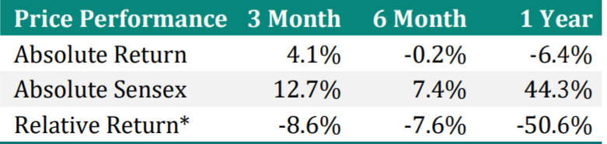

|  |  |  |  |
| --- | --- | --- | --- |
| **Consolidated (cr)** | **FY21A** | **FY22E** | **FY23E** |
| Sales | 12,883 | 14,043 | 15,461 |
| Growth (%) | 12.6 | 9.0 | 10.1 |
| EBITDA | 2,509 | 2,415 | 2,336 |
| EBITDA Margin (%) | 19.5 | 17.2 | 15.1 |
| Adj. PAT | 1,865 | 1,846 | 2,145 |
| Growth (%) | 31.3 | (1.0) | 16.2 |
| Adj. EPS | 77.4 | 76.7 | 89.1 |
| Growth (%) | 31.1 | (1.0) | 16.2 |
| P/E | 46.1 | 46.6 | 40.1 |
| P/B | 24.2 | 20.1 | 16.7 |
| EV/EBITDA | 35.0 | 36.3 | 37.4 |
| ROE (%) | 52.5 | 43.1 | 41.7 |
| D/E | 0.6 | 0.4 | 0.3 |

**Britannia Industries**

* **Britannia clocked an in-line revenue while EBITDA margin was lower than our as well as street’s expectation.**
* **Revenue growth remained moderated in 2HFY21.**
* **Domestic volume growth at 8% (negligible price hike) was much slower than ~17% in 1HFY21**
* **High debt, inter group transactions, and modest FY22 earnings.**
* Shutdown in business operation due to implementation of large scale digital project impacted primary billing for 3 days in Mar’21.
* Britannia (BRIT) 4QFY21 result was below our estimates
* **In Time Series Analysis, Britannia weightage Score is less than its Industry average.**

|  |  |  |  |  |
| --- | --- | --- | --- | --- |
| TIME SERIES ANALYSIS | | | | |
|  |  |  |  |  |
|  |  |  |  |  |
| **Industry Weightage Score** | | | **58%** |  |
| **Britannia Industries Ltd** | | | **43%** |  |

* **In Cross section Analysis also Britannia weightage is less than its Industry average.**

|  |  |  |  |  |
| --- | --- | --- | --- | --- |
| CROSS SECTION ANALYSIS | | | | |
|  |  |  |  |  |
|  |  |  |  |  |
| **Industry Weightage Score** | | | **3.9** |  |
| **Britannia Industries Ltd** | | | **3.53** |  |
|  | | |  |  |

Performance to Bench Mark Return

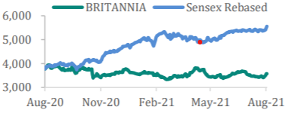

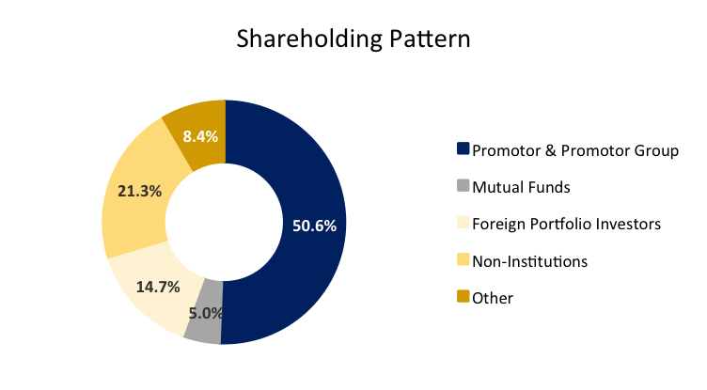

|  |  |  |  |
| --- | --- | --- | --- |
| **Shareholding %** | **Q3FY21** | **Q4FY21** | **Q1FY22** |
| Promoters | 50.6 | 50.6 | 50.6 |
| FII’s | 17.7 | 18.0 | 18.4 |
| MFs/Insti | 10.7 | 11.2 | 9.0 |
| Public | 15.6 | 15.7 | 17.7 |
| Others | 5.6 | 4.6 | 4.4 |
| Total | 100.0 | 100.0 | 100.0 |
| Promoters’ pledge | 0.0 | 0.0 | 0.0 |
| **Financial Summary** |  |  |  |

|  |  |  |  |  |
| --- | --- | --- | --- | --- |
| **Year-end: March** | **FY20** | **FY21** | **FY22E** | **FY23E** |
| **Net sales** | **115,995** | **131,361** | **144,055** | **158,637** |
| *Growth (%)* | *4.9* | *13.2* | *9.7* | *10.1* |
| Operating expenses | (97,564) | (106,269) | (118,365) | (130,194) |
| **EBITDA** | **18,431** | **25,092** | **25,690** | **28,444** |
| *Growth (%)* | *6.3* | *36.1* | *2.4* | *10.7* |
| Depreciation | (1,848) | (1,979) | (2,166) | (2,388) |
| **EBIT** | **16,583** | **23,114** | **23,524** | **26,056** |
| Interest paid | (769) | (1,109) | (1,053) | (1,000) |
| Other income | 2,794 | 3,129 | 3,442 | 3,786 |
| **Pre-tax profit** | **18,608** | **25,134** | **25,913** | **28,842** |
| Tax | (4,507) | (6,630) | (6,789) | (7,557) |
| *Effective tax rate (%)* | 24.2 | 26.4 | 26.2 | 26.2 |
| Minority Interest | (85.9) | 141.1 | (131.0) | (145.8) |
| **Net profit** | **14,015** | **18,645** | **18,993** | **21,140** |
| Exceptional items | (170) | 6 | - | - |
| **Adjusted net profit** | **14,185** | **18,639** | **18,993** | **21,140** |
| *Growth (%)* | *23.1* | *31.4* | *1.9* | *11.3* |
| *Shares o/s (mn nos)* | *240* | *241* | *241* | *241* |

**Profit & Loss Account (Rs mn) Cash Flow Statement (Rs mn)**

|  |  |  |  |  |
| --- | --- | --- | --- | --- |
| **Year-end: March** | **FY20** | **FY21** | **FY22E** | **FY23E** |
| Pre-tax profit | 18,438 | 25,128 | 25,913 | 28,842 |
| Depreciation | 1,848 | 1,979 | 2,166 | 2,388 |
| Tax paid | (5,033) | (6,328) | (6,789) | (7,557) |
| Chg in working capital | 1,511 | 1,156 | (33) | (38) |
| Other operating activities | (1,919) | (3,423) | 1,053 | 1,000 |
| **Cash flow from operations (a)** | **14,845** | **18,511** | **22,310** | **24,636** |
| Capital expenditure | (2,442) | (2,421) | (2,569) | (2,844) |
| Chg in investments | (14,151) | 7,033 | (131) | (146) |
| Other investing activities | 1,276 | - | - | - |
| **Cash flow from investing (b)** | **(15,316)** | **4,613** | **(2,700)** | **(2,990)** |
| Equity raised/(repaid) | 240 | 1,032 | - | - |
| Debt raised/(repaid) | 6,407 | 5,678 | (1,000) | (1,000) |
| Dividend (incl. tax) | (4,325) | (28,238) | (5,888) | (6,553) |
| Chg in minorities | - | - | - | - |
| Other financing activities | (1,742) | (909) | (1,053) | (1,000) |
| **Cash flow from financing (c)** | **579** | **(22,437)** | **(7,941)** | **(8,554)** |
| **Net chg in cash (a+b+c)** | **108** | **686** | **11,669** | **13,092** |

**Balance Sheet (Rs mn)**

|  |  |  |  |  |
| --- | --- | --- | --- | --- |
| **Year-end: March** | **FY20** | **FY21** | **FY22E** | **FY23E** |
| Net fixed assets | 19,033 | 19,118 | 19,521 | 19,978 |
| Investments | 18,989 | 13,852 | 13,852 | 13,852 |
| Other non-curr assets | 3,651 | 2,922 | 2,922 | 2,922 |
| **Current assets** | **36,750** | 44,197 | 57,169 | 71,758 |
| Inventories | 7,410 | 10,915 | 11,970 | 13,181 |
| Sundry Debtors | 3,204 | 2,573 | 2,821 | 3,107 |
| Cash and Bank | 1,229 | 2,113 | 13,782 | 26,874 |
| Marketable Securities | - | - | - | - |
| Loans and advances | - | - | - | - |
| **Total assets** | **78,422** | **80,088** | **93,463** | **108,509** |
|  | | | | |
| **Shareholders’ funds** | **44,028** | **35,476** | **48,581** | **63,168** |
| Share capital | 241 | 241 | 241 | 241 |
| Reserves & surplus | 43,788 | 35,236 | 48,341 | 62,927 |
| **Total Debt** | **15,141** | **20,872** | **19,872** | **18,872** |
| Secured loans | 15,141 | 20,872 | 19,872 | 18,872 |
| Unsecured loans | - | - | - | - |
| Other liabilities | 724 | 635 | 634 | 634 |
| **Curr Liab & prov** | **18,173** | **22,749** | **24,019** | **25,479** |
| Current liabilities | 16,261 | 18,874 | 20,145 | 21,604 |
| Provisions | 1,913 | 3,875 | 3,875 | 3,875 |
| **Total liabilities** | **34,038** | **44,255** | **44,525** | **44,984** |
| **Total equity & liabilities** | **78,422** | **80,088** | **93,463** | **108,509** |
| **Book Value (Rs)** | **183** | **148** | **202** | **263** |

**Financial Ratios**

|  |  |  |  |  |
| --- | --- | --- | --- | --- |
| **Year-end: March** | **FY20** | **FY21** | **FY22E** | **FY23E** |
| Adj. EPS (Rs) | 59.1 | 77.5 | 79.0 | 87.9 |
| *Adj. EPS growth (%)* | *23.2* | *31.1* | *1.9* | *11.3* |
| *EBITDA margin (%)* | *15.9* | *19.1* | *17.8* | *17.9* |
| *Pre-tax margin (%)* | *16.0* | *19.1* | *18.0* | *18.2* |
| *ROE (%)* | *32.8* | *46.9* | *45.2* | *37.8* |
| *ROCE (%)* | *31.6* | *39.3* | *37.1* | *34.2* |
| **Turnover & Leverage ratios (x)** | | | | |
| Asset turnover (x) | 1.6 | 1.7 | 1.7 | 1.6 |
| Leverage factor (x) | 1.6 | 2.0 | 2.1 | 1.8 |
| *Net margin (%)* | *12.2* | *14.2* | *13.2* | *13.3* |
| Net Debt/Equity (x) | 0.3 | 0.5 | 0.1 | (0.1) |
| **Working Capital & Liquidity ratio** | | | | |
| Inventory days | 23 | 30 | 30 | 30 |
| Receivable days | 10 | 7 | 7 | 7 |
| Payable days | 42 | 45 | 44 | 45 |

**Valuation**

|  |  |  |  |  |
| --- | --- | --- | --- | --- |
| **Year-end: March** | **FY20** | **FY21** | **FY22E** | **FY23E** |
| P/E (x) | 59.9 | 45.7 | 44.8 | 40.3 |
| Price / Book value (x) | 19.3 | 24.0 | 17.5 | 13.5 |
| PCE (x) | 53.0 | 41.3 | 40.2 | 36.2 |
| EV / Net sales (x) | 7.4 | 6.6 | 6.0 | 5.3 |
| EV / EBITDA (x) | 46.9 | 34.7 | 33.4 | 29.7 |
| *Dividend Yield (%)* | *0.5* | *3.3* | *0.7* | *0.8* |

**INVESTMENT RATING CRITERIA**

**BUY- In time series analysis and cross section analysis Britannia weightage score is more than industry average .**

**HOLD-Either in time series or cross section analysis ones’weightage score of Britannia industry is more than industry average and other one lower than industry average.**

**SELL-Both in time series analysis and cross section analysis Britannia weightage score is less than industry average.**

**COMPANY BACKGROUND-**

Britannia Industries is one of India’s leading food companies with a 100-year legacy and annual revenues in excess of Rs. 9000 Cr. Britannia’s product portfolio includes **Biscuits, Bread, Cakes, Rusk, and Dairy products including Cheese, Beverages, Milk**and **Yoghurt**.

Britannia is a brand which many generations of Indians have grown up with and is cherished and loved in India and the world over. Brand Britannia is listed amongst the most trusted, valuable and popular brands in various surveys conducted by prestigious organizations.

## Britannia - Company Highlights

| **Startup Name** | **Britannia Industries Limited** |
| --- | --- |
| Headquarters | [Kolkata](https://startuptalky.com/kolkata-startups/), West Bengal, India |
| Industry | Food Processing |
| Parent Company | Wadia Group |
| Founded | 1892 |
| CEO | Varun Berry (Since 2014) |
| Revenue | 11,878.95 crores INR (US$1.7 billion) - 2020 |
| Areas served | Worldwide |
| Website | www.britannia.co.in |

**DISCLAIMER-**

The information contain here in is from the public domain or sources believed to be reliable, but do not make any representation or warranty that it is accurate, complete or up-to-date and it should not be relied upon as such. While reasonable care has been taken to ensure that information given is at the time believed to be fair and correct and opinions based thereupon are reasonable, due to the very nature of research it cannot be warranted or represented that it is accurate or complete and it should not be relied upon as such. In so far as this report includes current or historical information, it is believed to be reliable, although its accuracy and completeness cannot be guaranteed.

The information is not intended to be used as the basis of any investment decisions by any person or entity. This information does not constitute investment advice, nor is it an offer or a solicitation of an offer to buy or sell any security

*2*